EXPERIMENT- 02
Convert an Image to Blur
Aim
To write a Python code to read an image and apply Gaussian Blur using OpenCV for reducing noise and smoothing the image.
Input Image
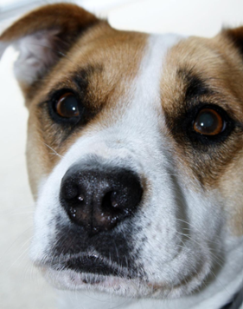
Code
import cv2
from google.colab.patches import cv2_imshow
from google.colab import files
uploaded=files.upload()
image_path=list(uploaded.keys())[0]
image=cv2.imread(image_path)
if image is None:
print("Error: Image not found")
else:
blurred_image=cv2.GaussianBlur(image,(5,5),0)
print("Original Image")
cv2_imshow(image)
print("Blurred Image")
cv2_imshow(blurred_image)
Output Image
Blurred Image
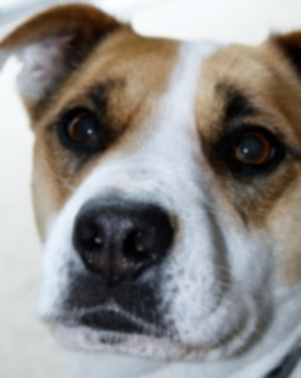

Result
Thus, the image was successfully blurred using OpenCV Gaussian Blur.

